Hess' law states that the overall enthalpy change to form products is the same, regardless of which route was taken to get there.

If the reaction is for a formation reaction, arrows point upwards towards the main equation.

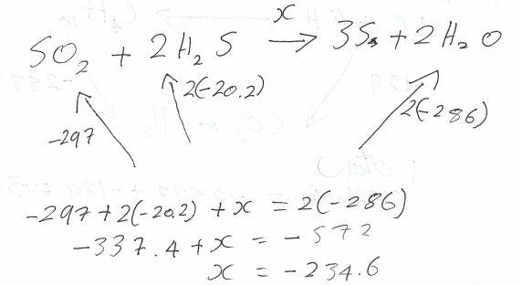

If the reaction is for a combustion reaction, arrows point downwards from the main equation.
